**Exp no. 5 CONCURRENT TCP/IP DAY-TIME SERVER**

**AIM:** To implement date and time display from client to server using TCP Sockets

**DESCRIPTION**:

TCP Server gets the system date and time and opens the server socket to read the client details. Client sends its address to the server. Then the client receives the date and time from server to display. TCP socket server client connection is opened for communication. After the date time is displayed the server client connection is closed with its respective streams to be closed.

**ALGORITHM:**

**Server**

1. Create a server socket and bind it to the port.
2. Listen for new connections and when a connection arrives, accept it.
3. Send server’s date and time to the client.
4. Read the client's IP address sent by the client.
5. Display the client details.
6. Repeat steps 2-5 until the server is terminated.
7. Close all streams.
8. Close the server socket.
9. Stop.

**Client**

1. Create a client socket and connect it to the server’s port number.
2. Retrieve its own IP address using built-in function.
3. Send its address to the server.
4. Display the date & time sent by the server.
5. Close the input and output streams.
6. Close the client socket.
7. Stop.

**Program**

**Server_DT**

import java.net.*;

import java.io.*;

import java.util.Date;

public class Server_DT {

    public static void main(String[] args)throws IOException {

        // TODO code application logic here

        //Step 1. Reserve a port number on the Server to offer this service

        ServerSocket ss= new ServerSocket(5000);

        //(Optional)To confirm Server Reserved specified port or not

        System.out.println("The Server has reserved port No.: "+ss.getLocalPort()+" for this Service");

        //Step 2. Now create a Client Socket on Server for Bidirectonal Communication.

        //Socket is created only when client communicates with the server

        Socket cs=ss.accept();

        //To confirm Server communicated through the socket or not

         System.out.println("Client with IP Address "+cs.getInetAddress()+" has communicated via port

No.: "+cs.getPort());

        Date d=new Date();

        String s="Current Date & Time on Server is:"+d;

        //Send String s to client via client socket

        PrintWriter toclient=new PrintWriter(cs.getOutputStream(),true);

        toclient.print(s);

        toclient.close();

        cs.close();

        ss.close();

       }

}

**Client_DT**

import java.net.*;

import java.io.*;

public class Client_DT {

    public static void main(String[] args) throws UnknownHostException,IOException {

        // TODO code application logic here

        //Step 1. Create a client socket to connect to Server

        Socket cs= new Socket("LocalHost",5000);

        //To confirm Client is communicating through the port

        System.out.println("Client "+cs.getInetAddress()+" is communicating from port No.:

"+cs.getPort());

        //Receive Date Sent by Server

        BufferedReader fromserver=new BufferedReader(new InputStreamReader(cs.getInputStream()));

        System.out.println(fromserver.readLine());

        fromserver.close();

        cs.close();

    }

}

**Output**

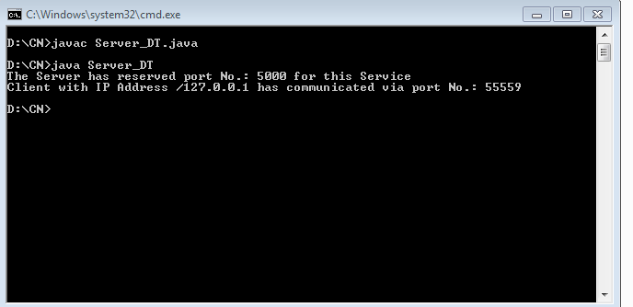  
  
  
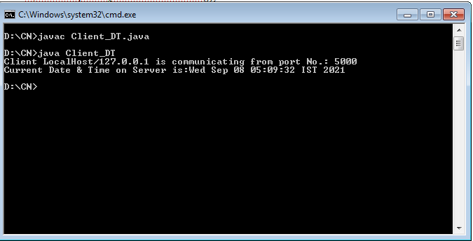

**Result**: Thus the concurrent TCP/IP Day-Time Server has been implemented